Contents
Contents 1
Introduction 2
Getting Started 4
Your Values 5
Your core values 5
How are you living now? 6
Shadow beliefs 7
Your Vision 8
Your story 8
Your fantastic day 8
Wheel of Life 9
Your transformative purpose 10
Your Year in Review 12
Your successes 12
Favorite experiences 16
Gratitude list 17
Key health metrics 18
Goals 19
Dreaming 19
The goal stack 21
Crazy clear goal setting 24
Reviews 25
In Closing... 28
About the Authors 29
Cliff Guren 29
Glen Lubbert 29
Thanks 30
Appendix 1: Wheel of Life Templates 31
Appendix 2: Weekly Review Checklist 33
Copyright 34

Introduction
Welcome to More About You: A Workbook for Your Personal Annual Review and Plan for the Year Ahead. This guide helps you build a foundation for achieving your personal goals in the year ahead. Most annual review processes begin by looking back—at your accomplishments for the year, key experiences, and missed opportunities. Our process is different.

First, we begin with your values. We ask you to revisit your core values and beliefs, reconnect with your vision for your life, update your personal story, and describe your perfect day. We start with these things because we believe your core values illuminate every aspect of the review process, from what makes up a success (or failure), to what makes your perfect day “perfect.”

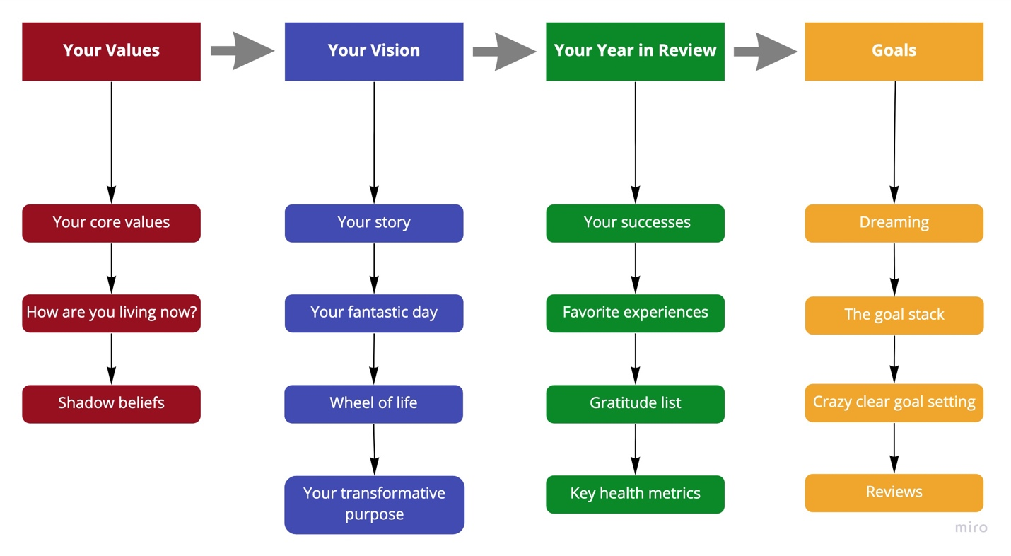

Next, we move to your vision: your personal narrative, your aspirations, and the key areas of your life that are the focus of most of your time and energy. This exercise in personal storytelling helps you articulate your narrative for the year ahead and position yourself for growth.

The third section of the review focuses on capturing the most influential moments of the past year. Our review process primarily focuses on your successes. Yes, you can learn from your failures, but there's a time and place for everything... We believe your annual review is a way to use your successes—the things you've accomplished and are most proud of—to help you build a year ahead that's about more: more of the same positive energy, more growth, and more successes that align with your values and vision.

The last section of the workbook focuses on capturing, clarifying, and achieving your goals. It begins with dreaming. Every goal is attached to a dream: without an associated dream, a goal has no emotional power. We then move to the goal stack and show you how your daily tasks, when properly clarified and aligned with your goals, drive you toward your long-term aspirations. We close with the most important tool in your productivity system: reviews. Weekly and monthly reviews are essential to keeping you on track, especially during times of uncertainty.

While we’ve laid out a path for your annual review process, you don’t have to follow it! You don’t have to complete the sections in the workbook in order, or even complete all the sections. And, you don’t have to complete your annual review in one sitting. In fact, it’s a good idea to give yourself a break as you move from section to section. Take a few minutes to read through the questions in the next section you’re going to focus on, then step away from your review for a few minutes, hours, or even days. When you return to your review, your mind (which is always working) will be primed to respond to the questions in the next section.

We’re sharing the workbook as a Microsoft Word document so you can type your responses in the Word file. We’ve also created a PDF version you can print and use offline if you prefer to respond in longhand. It doesn’t matter if you type or write out your answers—what matters is that you find a quiet place where you can work on your review without distractions.

The ✏️ emoji is your invitation to respond.

Let's get started!

Getting Started
In their book, Designing Your Life: How to Build a Well-Lived, Joyful Life, Bill Burnett and Dave Evans outline the key elements of a well-lived, joyful life:

- A well-designed life is a life that is generative:
  - It’s constantly creative and productive.
  - It changes and evolves.
  - And there’s always the possibility of surprise.
- The biggest reframe is that your life can’t be perfectly planned: there isn’t just one solution to your life—and that’s a good thing.
- A coherent life is one lived in a way that enables you to clearly connect the dots between three things:
  - Who you are.
  - What you believe.
  - What you’re doing.
- You live and design your life in collaboration with others.

“True happiness,” they add, “comes from designing a life that works for you.”

If this is your first time doing a personal annual review, know this isn’t a pass/fail test. It’s a guided conversation. You are about to start a process of insight, reflection, and renewal designed to help you surface and connect with the values, experiences, dreams, and purpose statements that guide your day-to-day life. Whatever you write is good enough for now. The important thing is to get started with your first annual review.

We’ve provided lots of questions to help connect those dots: you can answer as many or as few as you like. Each year you do this exercise, you peel back another layer and learn more about yourself—where you’ve been and where you want to go.

If you’re already doing an annual review, we hope this gives you new ideas to help you on your journey.

Your Values
“He who has a why to live for can bear almost any how.”
— Friedrich Nietzsche, German Philosopher

Values define your life. They are the things that you believe are important in the way you live and work. Whether or not you’re conscious of them, your values inform how you make decisions. Defining your values helps you be more intentional about the choices you make, both large and small.

Values also help you define a purpose to pursue, a north star. A values-based purpose is a key component to your goal stack. When your values and actions align, you can achieve more in less time and do more stuff you care about. This exercise is an integral ingredient to the goal stack formula for limitless momentum and motivation.

Your core values
Answering these questions helps illuminate your core values.

- Who do you admire? List three to five people you admire.
✏️

- What qualities do the people on your list have you admire? What behaviors do they have that you’d like to emulate?
✏️

- What are the pivotal moments in your life when you’ve felt that your actions and values were most closely aligned?
✏️

- What principles guided you in those moments?
✏️

- Look at the answers to these questions and ask yourself, what are the core values that drive your life and work? Keep this list to around five core values. You want to be able to easily reference them when making decisions.
✏️

Another way to identify and prioritize your values is through the Values Card Sort online game. The game includes one hundred value cards that you rank, sort, and respond to. It’s a fun way to understand your values while also developing your values vocabulary.

Learn more about the Values Card Sort online game and get started.

Additional resources on values:
- What Are Your Values?
- 6 Ways to Discover and Choose Your Core Values
- Core Values List

How are you living now?
These questions help understand what you can do more of.

- What went better this year?
✏️

- What did you do this year, even the smallest thing, that you're proud of?
✏️

- What did you do well this year? How did you do it? How did you gain the skills to do it?
✏️

- How are you living and working in accordance with your deepest values right now?
✏️

- How can you set a higher standard in the future?
✏️

Shadow beliefs
A "shadow belief" is an unconscious belief that influences your entire life, tells you what you can and cannot do, and drives your behaviors. Understanding shadow beliefs will help you see your blind spots. Shadow beliefs cause you to make the same mistakes over and over again.

- What are your shadow beliefs? Common shadow beliefs include:
  - There is something wrong with me.
  - I cannot trust anyone.
  - I'm not lovable.
  - I don't deserve to have what I want.
  - Love does not last.
  - I am worthless.
  - I am never going to be successful.
✏️

- To help develop from your shadow beliefs, make a list of the advice you give others and ask yourself if the advice is appropriate for your life.
✏️

Additional resources on shadow beliefs:
- Shadow Psychology
- 7 Clues You're Unknowingly Sabotaging Your Strengths
- Why We Sabotage Ourselves (YouTube Video)
- 8 Magic Words to Change Negative Into Positive Self-Talk

Your Vision
“It's like everyone tells a story about themselves inside their own head. Always. All the time. That story makes you what you are. We build ourselves out of that story.”
— Patrick Rothfuss, American Fantasy Writer

Storytelling is powerful. Telling stories is a fundamental part of being human. Stories let us share information in a way that creates an emotional connection. And as Stanford’s Professor, B.J. Fogg and author of Tiny Habits: The Small Changes that Change Everything writes, emotions create habits. Having a storyline helps your vision become more visceral and allows the habits you want to form more easily.

These exercises help create the story you want to live. Writing your story helps you make decisions that align with your values and priorities. Engage your senses. The more details you capture, the easier it will be to focus on your vision.

Your story
Imagine you were talking to a friend about a movie where the new year turns out to be just right for you. Write one or two sentences, or even just a phrase that describes what you would notice that tells you everything is just the way you want it to be.

In one word or phrase, summarize this best-for-you-year: This is the year of…
✏️

Additional resources on crafting your story:
- What’s Your Story?
- How to Tell Your Own Life Story

Your fantastic day
- If your life a year from now could be as fantastically spectacular as you could possibly imagine, what would a typical day look like? What would you notice, even the smallest thing? What would others notice about you? Visualize the day in as much detail as you can, engage your five senses.
✏️

- What are your best hopes for the year ahead? What do you know about yourself that tells you that you have what it takes to make it happen?
✏️

Wheel of Life
It’s not always easy to know if your life actually reflects your values. We spend most of our time “down in the weeds.” Getting perspective can be hard. Fortunately, there are tools that help you rise to the challenge. One such tool is the “Wheel of Life.” It gives you a “helicopter view” of your life so you can see whether the investments you’re making and the results you’re getting align with your values. Below you’ll find a sample Wheel of Life.
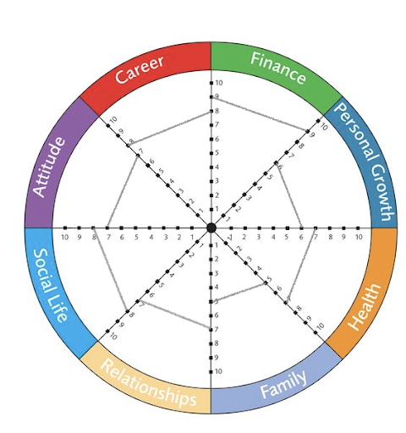

The circle is you—the whole you. The slices are the aspects of your life that are important to you, that add up to the whole you.

You begin the Wheel of Life exercise by picking an area and thinking about how closely your life right now aligns with your priorities and values for that aspect of your life. Using a scale of 1 to 10, where 10 is very closely aligned and 1 is the opposite, draw a line across the slice. Complete this assessment for each slice in the wheel.

Does the wheel reflect your values and priorities? For example, if your family score is low, and family is important to, that’s a signal that your life is out of alignment with values and priorities. There’s no one right picture for everyone… The idea isn’t to get a “perfect” score that reflects someone else’s values or idea of a well-lived life. The idea is to align your values with the life you’re living and to address the disconnects you find.

You’ll find two Wheel of Life images in the appendices: one with category labels and one without.

Print the one with labels if it reflects your values. If not, print the wheel without labels and enter your own categories. Below are some sample categories to consider if you’re starting with the wheel without labels:

- Health / Physical
- Family
- Career
- Financial
- Social
- Intellectual
- Spiritual
- Attitude
- Personal Growth
- Relationships

Additional resources on the Wheel of Life exercise:
- The Wheel of Life
- The Four Burners Theory

Your transformative purpose
Review the storyline and fantastic day you wrote. Knowing what you know now, how might you change it?

Finally, review these two and your values and ask yourself one of the most important questions you need to build a powerful goal stack for the year ahead: What is your transformative purpose? How do you want to make an impact?

Here’s how Bold author Steven Kotler describes your transformative purpose: “Passion, for all its upside, can be a fairly selfish experience. Being all consumed by something means just that—you’re all consumed. There’s not much room for other people. Thus, it’s critical to turn passion into purpose—that’s both how you build businesses around your passion and how you guard against being swallowed whole by your new love.”

Here’s an exercise to help:

- List out five things you’re curious about.
✏️

- What’s the one thing that intersects all five things?
✏️

- What are five big problems that surround this intersection?
✏️

- Describe your transformative purpose in one sentence.
✏️

Don’t worry about being permanently attached to this purpose, especially if it’s the first time defining it. Play with it. Share it socially. Try it on for two to three months. Refining this can be a lifelong pursuit.

Additional resources on your transformative purpose:
- The Passion Recipe: Four Steps to Total Fulfillment
- Discovering Your Massively Transformative Purpose
- What Is Your Massive Transformative Purpose (MTP)?

Your Year in Review
“Without reflection, we go blindly on our way, creating more unintended consequences, and failing to achieve anything useful.”
— Margaret J. Wheatley, Writer and Management Consultant

Your year in review is a powerful tool for highlighting accomplishments, providing insights into lessons learned, and focusing on your goals for the year ahead. It's one of the most impactful activities you can do to center yourself and build toward your north star (your transformative purpose).

Your successes
In this section, you’ll use the categories from your Wheel of Life exercise to answer three questions for each category in the wheel:
- What went well this year? Why?
- What surprised you?
- What did you learn?

For example:

- Health
  - What went well this year? Why?
  - What surprised you?
  - What did you learn?

It’s helpful to list your successes quarter by quarter. Use your calendar to spark your memory. A tip for future reviews is to keep a note (on your computer or in a journal) of your successes each day, week, or month. Not only is this helpful throughout the year to see your progress, but it also makes this part of your review easier.

When looking at your successes in each category, consider even the tiniest thing you could add to the list. What do you do when it’s the day you feel the least motivated? Do you floss your teeth every day or make your bed every day? There’s strength there that shows the resilience you have, no matter the challenge. Those strengths are useful in other areas where you want to improve.

As you go through your list of successes, keep a note of ideas for your year ahead. What do you want to do more of? What do you want to do less of? Who do you want to spend more time with? Who do you want to spend less time with?

Note: If you created your own categories for your Wheel of Life exercise, delete (or strike-through) the category names below, then add the categories you created.

- Finance ________________
  - What went well this year? Why?
✏️

  - What surprised you?
✏️

  - What did you learn?
✏️

- Personal Growth ________________
  - What went well this year? Why?
✏️

  - What surprised you?
✏️

  - What did you learn?
✏️

- Health ________________
  - What went well this year? Why?
✏️

  - What surprised you?
✏️

  - What did you learn?
✏️

- Family ________________
  - What went well this year? Why?
✏️

  - What surprised you?
✏️

  - What did you learn?
✏️

- Relationships ________________
  - What went well this year? Why?
✏️

  - What surprised you?
✏️

  - What did you learn?
✏️

- Social Life ________________
  - What went well this year? Why?
✏️

  - What surprised you?
✏️

  - What did you learn?
✏️

- Attitude ________________
  - What went well this year? Why?
✏️

  - What surprised you?
✏️

  - What did you learn?
✏️

- Career ________________
  - What went well this year? Why?
✏️

  - What surprised you?
✏️

  - What did you learn?
✏️

Once you’ve ranked all categories, ask yourself the following questions:
- What are things you will START doing to more align with your current values?
✏️

- What are things you will STOP doing, re-prioritize, or delegate?
✏️

Favorite experiences
This exercise helps you recollect your favorite experiences of the past year. Collecting and revisiting your favorite memories of the year is an effective way to ensure that you’re closing out the whole year with clarity. Too often, the experiences of the recent past set the tone for the whole year. The challenges of November cloud over the joys of February. This is especially true this year—a year that’s commonly referred to as the year of the “blur.” The pandemic, the lockdowns, and the changes in our daily routines have warped our sense of time. It’s been a stressful year… Your list of favorite experiences may be shorter than you’d hoped but be sure to give those moments of joy their due.

Don’t feel compelled to respond to every question below. Pick the categories that are most important to you. And don’t feel compelled to list the suggested number of experiences for each category—treat the numbers as upper limits. The goal isn’t to list every experience in each category, just the highlights.

Often your favorite apps will do this for you with a list of your highlights of the year (for example, your most played songs of the year). These tools can help you easily build some of your favorite experiences lists.

Consider sharing your favorite photos, videos, and lists with your friends and family.
- Photos/videos of the year: Review your digital and print photos, and your videos. Be sure to check your phone, computer, and cloud libraries. Create an album of your favorite 100 photos/videos. Jot down a few notes on the memories your favorite photos evoke.
✏️

- Music of the year: Create a list of your favorite 25 songs and/or 10 albums of the year. Make a playlist for yourself.
✏️

- Movies/television shows and series: Create a list of your 10 favorite movies, television shows or series of the year.
✏️

- Books/Articles: Create a list of your 10 favorite books and/or articles.
✏️

- Courses/Learning experiences: Create a list of your favorite courses and/or learning experiences of the year. Be sure to include why the course or learning experience made your list. Was it the course material? The presenter? How what you learned changed your life?
✏️

- Events: Create a list of your favorite events. Include live events as well as online events.
✏️

- Memories: Create a list of your favorite memories of the year. Include the moments that brought you the most joy, the moments that touched your heart, and your lightbulb moments.
✏️

Gratitude list
Gratitude is the practice of focusing on what you have rather than what you don’t. It’s about bringing warm, kind attention to the loved ones, colleagues, animals, natural surroundings, experiences, and things in your life that sustain you. Studies show “counting your blessings” regularly creates and sustains a positive attitude, increasing your happiness, physical health, and your likelihood of achieving your goals. Gratitude also connects you to the world around you: when you give thanks to others you acknowledge that positive things have happened in your life and that those good outcomes are due, at least in part, to the love, support, and contributions of others who care for you.

- List five to ten good things that went well for you this year. Take a few moments to reflect on why these things went well and who, if anyone, you want to thank.
✏️

- List the five most important people in your life. Now take a few moments to reflect on what your life would be like without those people.
✏️

- List five to ten things in your life that you are the most grateful for, other than the people in your life. The gifts that are a combination of work and luck, such as your health, your home, or your natural surroundings, that you want to acknowledge and give thanks for.
✏️

- Take a few minutes to write notes of thanks to the people who have positively affected your life in the past year. A simple acknowledgement will do: “Jen, thank you for your help at work this year. I wouldn’t have made it through 2020 without your support, wise words, and friendship.” You will feel good expressing your gratitude, and your thanks will let the recipient know that their support made a difference in your life.
✏️

If things were terrible for you this year, what did you do to keep things from getting even worse? What small thing did you do to make it bearable for yourself? For people around you?
✏️

Additional resources on gratitude:
- Gratitude
- Giving Thanks Can Make You Happier
- How Gratitude Changes You and Your Brain
- What is Gratitude and Why Is It So Important?
- The Science Behind Gratitude (and How It Can Change Your Life)

Key health metrics
Keeping track of your key health metrics helps maintain focus on your health trends: Am I increasing the number of steps I take year over year, or is it declining? Is my body fat percentage increasing or decreasing? What you want to look at is the direction of each area of your health.

The more years of data you have, the more valuable this directional information will be. Even if you haven’t tracked this data before, you may already have several years of trends in your pocket. Nearly all phones have a health tracking app that at least shows the steps you are taking.

Use the information you have easy access to and this Google Sheets template to track your key health metrics and the direction they are heading.

Goals
“Dream and give yourself permission to envision a You that you choose to be.”
— Joy Page, Actress

“You do not rise to the level of your goals. You fall to the level of your systems.”
— James Clear, Author of Atomic Habits

Setting goals is a book-length topic… Far more than we can cover in this workbook. What we can do here is introduce a few key concepts and a simple system that will help you move toward your goals.

Throughout this process, you’ve examined your values, your vision, your successes, and the sources of your feelings of gratitude. You have a pretty good idea of what your ideal day will look like and the person you’re striving to be. You’ve also considered your transformative purpose. At this point, you know (or have a sense of) what you want to optimize toward or build a system around. Now, when you face a decision, you can ask yourself: What would the person I’m striving to become choose to do?

For example, if your goal is to become a healthy eater, ask yourself, “What would a healthy eater choose or do in this circumstance?” You can then look at building habits that reinforce this identity. As James Clear, author of Atomic Habits, points out, your long-term success is more about your trajectory than any specific goal. Are you moving in the direction of the person you want to be and the impact you want to make?

This section introduces four tools that will help you identify, articulate, clarify, and achieve your goals: dreaming, the goal stack, crazy clear goal setting, and reviews.

Dreaming
Before you begin creating goals, dream. Every goal is attached to a dream: without an associated dream, a goal has no emotional power, and as we previously noted, emotions create habits. The more detailed the dream, the more your brain will believe it’s already happened. Your brain is a prediction engine. Dreaming makes it more likely you’ll achieve the outcomes you want from your new year planning process by priming that prediction engine.

“Prediction is such a fundamental activity of the human brain that some scientists consider it the brain’s primary mode of operation,” neuroscientist Lisa Feldman Barrett wrote in her book How Emotions are Made: The Secret Life of the Brain. “Everything you feel is based on prediction from your knowledge and experience. You are truly an architect of your experience. Believing is feeling.”

As the architect of your experience, answer the following questions in as much detail as you can. There are several questions that ask you to look at your outcomes through the eyes of the most important people in your life, your “VIPs.” This exercise helps you get out of your own negativity bias as you go through the year, seeing your progress through their perspective. These questions also highlight the strengths and skills you already have that you can lean on for resilience when life gets challenging.

- Suppose the next year went exactly the way that was right for you: At the end of the year, what would you notice you had done? What else? What else? What else? Add as many details as possible. Aim for a list of 25 associated outcomes.
✏️

- What difference will doing those things make? (For example: “Taking a skills improvement course each morning would allow me to move up in my career and make more money so I can buy a bigger house for my growing family where we can share happy memories together.”)
✏️

- What would tell you that doing what you did had been worth doing? (For example: “My children work hard on their education because they see my example.”)
✏️

- What would VIPs notice that would tell them what you had done had been the right thing for you? (For example: “I would have a smile on my face each time they saw me.”)
✏️

- If a VIP hadn't seen you for the year and then saw you, what would they notice about you that would tell them you were [fill in with word/description of your preferred future]. (For example: “I was smiling and giving them a big hug full of love. They could see my excitement as I told them about the things I’d learned.”)
✏️

- What do your VIPs see in you that tells them you can make the best of next year? (For example: “They saw I had time for my learning, my work, my family and my hobbies since I had scheduled my calendar with intention during a regular weekly review process.”)
✏️

- What would your VIPs notice that tells them you're making progress? (For example: “I celebrated with them each section of the course that I completed.”)
✏️

- What do you know about yourself now that tells you have what it takes to make this next year best for you? (For example: “I know I’ve been through hard times before and had the resilience to keep going. I keep or start a list of the strengths I used in the past, even the smallest ones.”)
✏️

- What's one clue, even the smallest, that tells you you're on the right path to make the coming year just right for you? (For example: “I completed some or all of this workbook.”)
✏️

- What are clues you’d notice that would tell you you're making progress? (For example: “I created a note with several skills courses that I can take that will help in my career direction. I signed up for a course. I completed the first module for the course.”) These clues are the seeds for creating your goals.
✏️

Additional resources on dreaming:
- How To Use Goals and Dreams to Achieve Personal Success

The goal stack
Your goal stack is your complete set of goals—from your transformative purpose down to your daily to-do tasks. The goal stack is in part about clarifying your intention, making the big decisions up front so you eliminate the uncertainty and little decisions that drain your energy and ability to focus. Knowing your goal stack reduces your cognitive load and stress, allowing for more in-the-zone flow moments.

Type | Timeframe | Description
Transformative Purpose | Lifetime | How you want to make an impact.
High Hard Goals | 1 to 10 years | Goals that will take more than a year to achieve and also make a significant impact on your progress toward achieving your transformative purpose.
Chunked Goals (or Projects) | Weekly, monthly, quarterly, annual | These are goals that are going to take weeks or months. Chunked goals are often projects that require the completion of a number of related steps.
Clear Goals | Today | These are goals you want to accomplish today, such as “Write a blog post,” “Paint the bedroom,” or “Reach out to a colleague.” The time required to complete these goals should be scheduled on your calendar.
To-Dos (or tasks) | Today | These goals are even more granular than your clear goals. For example, writing the blog post today may include a call to a colleague and reviewing notes from a research paper—it depends on how much detail you need or track and complete the steps required to accomplish the task. The nice thing about granular to-dos is completing each one gives you a small win and jolt of forward momentum.
The graphic below illustrates how your daily to-dos and goal stack help you drive toward your transformative purpose.
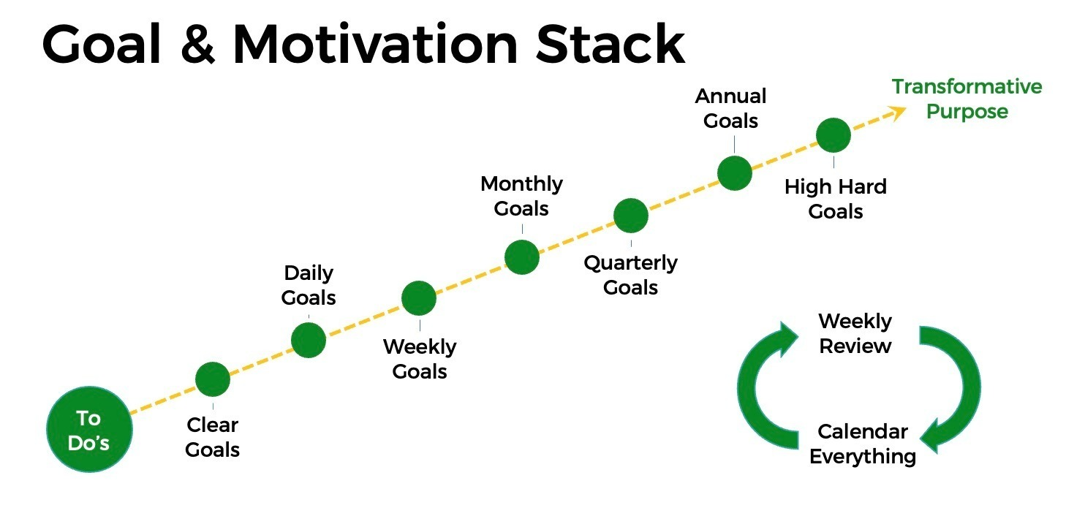
Keeping your tasks and goals aligned enables you to tap into your intrinsic motivation throughout the year and more easily achieve flow in all your projects. As you’ll learn below, the weekly review is the nervous system of your goal stack. Regular reviews transform your goals from a static note you look at a couple times a year into a guiding force that keeps you on track all year long.
Make SMART goals even smarter
You’ve probably heard about SMART goals: goals that are Specific, Measurable, Achievable, Relevant, Time-bound. For example, “Do 30 minutes of exercise Monday, Wednesday, and Friday by walking at lunchtime starting on Monday.” Many productivity experts recommend you craft SMART goals for all your projects.
While SMART goals can be helpful in many cases, they can also limit and undermine your success, especially in dynamic or uncertain environments. When we face change, our brains need to make new connections. Dynamic and uncertain environments require goals that are flexible—goals that are focused more on the trajectory of our progress rather than lots of specific success criteria. If you use SMART goals, answering the following two questions you began to explore in your dreaming step above will help you viscerally connect with the broader goal and help you be more flexible if/when you face unexpected changes:
- What will be the result (outcome) of reaching the goal?
- What difference will the outcome make in your life?
Here’s an example:
SMART goal: Do 30 minutes of exercise Monday, Wednesday, and Friday by walking at lunchtime, starting on Monday.

- Outcome: I’ll have more energy, be stronger, sleep better, lose weight, fit into my favorite clothes.
- Difference: I’ll feel happy and excited about doing physical activities, like go biking with my kids, go out dancing with friends on Friday night, and join a community basketball team. I’ll be more alert at work and get more work done without putting off things.
To stick with the hard work of behavior change, create a clear picture of how your life will be after you reach your goal. Focus on the difference the outcome will make in your life. You may want to revisit your dreaming questions above. You’ll find keeping these two things in mind will give you the added resilience you need to successfully absorb and manage unexpected change.

Crazy clear goal setting
One challenge with goal setting is being specific enough. When your goals are too vague, you’re less likely to achieve the outcome. The following protocol can help you systematically clarify your goals and effectively leverage the clear goals trigger for faster, more reliable access to flow. When you feel you’re starting to struggle or are stuck, use this protocol to refocus your goals.
Phase 1: Pre-Task Clear Goal Setting
- Step 1: Define the task
Usually, what we think is a single clear goal is really a cluster of goals. For example, the broad goal “Create meeting presentation” actually includes several goals.
- Step 2: Scope the clear goals living inside the task.
For example, “Develop outline for presentation, choose template, create headings for individual slides” and so forth.
- Step 3: Order the goals in the sequence they need to be addressed.
- Step 4: Make your goals even clearer.
For example, rather than writing “Develop outline for presentation,” break it down further into even more specific goals, such as “Develop outline for presentation, including section, topic, and subtopic headings, with notes on sources cited.”
- Step 5: Execute!

Phase 2: Mid-Task Clear Goal Reviewing

- Step 1: Write clear goals in your note-taking app, where you can easily see them.

- Step 2: Reset clear goals.

- Step 3: Revisit as a course correction mechanism such as your weekly review.

Phase 3: Go Clearer

If you continue to be blocked from getting projects started or not getting into flow, make your goal clearer until any resistance associated with beginning the task falls away.

Additional resources on setting goals:
- 15 Best Goal Setting Books to Read
- Discovering Your Massively Transformative Purpose (YouTube video)
- Locke's Goal Setting Theory
- When SMART Goals Are Not So Smart

Reviews
Once you’ve created your goals, you’ll want to put a review process in place. Regular reviews are the key to keeping yourself on track and adjusting to the changes that inevitably come along. The importance of weekly, monthly, and quarterly reviews can’t be stressed enough: like the nervous system in your body, regular reviews keep your values, goals, and daily activities connected. Add time for your regular reviews to your calendar as recurring events to help ensure you stay aligned with your values and goals.

Quarterly Review

Your quarterly review can be as simple as asking yourself: What’s the number one thing that is going to positively impact my annual or high hard goal? Or, it can be a more methodical review and alignment of your quarterly and annual goals, reviewing your goal stack from top to bottom. The key is pausing to assess your progress quarterly and re-prioritizing your project list if you’re not making enough progress on your annual goals.

Monthly Review

It’s too easy to get pulled off track day-to-day or week-to-week and lose sight of your quarterly and annual goals. Your monthly review is a check-in on your progress toward your quarterly goals and priorities. This is where you identify your unlocking moves—the key actions that will help you move closer to achieving your quarterly goals.

Weekly Strategy Review Session

The weekly review is a more granular review and one of the most valuable things you can do to stay on track, reduce your cognitive load and use your time in the most productive way. It’s the time when you dial in your ability to achieve your immediate goals and complete your projects. The list below outlines a simple weekly review process. We’ve also included this suggested weekly review sequence as a checklist in the Appendix. Use it to get started doing regular weekly reviews.

- Review and list your successes from the previous week in a note. Your weekly notes on your successes will be helpful when you look back at the year during your next annual review exercise. (Consider creating a “My Successes for 2022” note.) It’s also great to review your successes monthly. Celebrate them, even if it’s just a smile after you’ve added the success to your list. This fills your brain with the feel-good neurotransmitter, dopamine and helps keep momentum.
- Close your open loops from the previous week. Search your email and physical mail, to-do app, note-taking tools, and any other places you save items for later review during your day-to-day activities, for any open loops that need to be addressed in the coming week.
- Assess your weekly goals against your monthly goals to determine if you’re maintaining your focus and are making progress toward your monthly goals. If not, take some time to figure out how you’re spending your time. If new, urgent, and important priorities/goals have come up, reassess your monthly goals and make changes if necessary.
- Set your top three priorities/goals for the coming week. Write them down so you can review them the following week.
- Set daily clear priorities/goals for the coming week. Identify three priorities for each day and determine which one is the one Most Important Task (MIT) for each day. The MIT is the one thing you will get done that will help determine whether your day was a success.
- Add all your to-do tasks into your task manager. Make sure you’ve included everything you identified in your review of your open loops from the previous week.
- Block out the time you’ll need for your top priorities on your calendar.

  - Be sure you have blocked off all your recurring events, especially ones that will help you maintain the priorities you outlined in your Wheel of Life—including workouts, deep work blocks, learning sessions, family time, a weekly strategy review session, and recovery time.
  - For each of your daily priorities, block off time on the calendar. It can also help to include the outcome and difference spending time on each priority will make on your calendar event to connect the day to your quarterly and annual goals.

This simple review session will help you get started. As you learn more about your individual workflow, you can customize and expand on it. Remember to celebrate all your wins no matter how small, from a high hard goal all the way to your daily to-dos. Little wins increase momentum while also releasing habit-forming dopamine. Celebrating your successes builds habits and keeps you coming back for more.

Additional resources on reviews:
- The Weekly Review
- Back to Basics: Your Weekly Review
- The One-Touch Guide to Doing a Weekly Review
- A Guide to Writing Weekly, Monthly, and Annual Reviews

In Closing...
Congratulations, you’ve completed your annual review! For some of you, this is your first annual review. We hope it’s one of many…

Reviewing, reflecting, and setting goals isn’t a “one and done” annual event. It’s a process, a tool, a way of designing a life that works for you, in harmony with your values and priorities. We encourage you to make a purpose-filled year: one that begins with setting goals that are meaningful to you and ends with a celebration of your desired accomplishments.

If you have questions about this workbook, your annual review, or creating a system to better connect with your values, get closer to your vision of your fantastic day, and help achieve your transformative purpose, please use this form to contact us.

Finally, if you like the workbook, please consider joining the mailing list for our SecondBrain SuperPowers course. The annual review process will help you clarify your values and goals. Our SecondBrain SuperPowers course will help you achieve your goals, enhance your creativity, and become more adept at getting into and recovering from flow states. Join the course mailing list to learn more about the course and upcoming cohorts.

We wish you all the best in the year ahead!

Cliff & Glen

About the Authors

Cliff Guren
My passion is exploring and enabling creativity in all its forms. When I earned a Master of Fine Arts degree years ago, I thought I’d spend my life writing and teaching. But things don’t always turn out exactly the way you think they will… I wound up spending most of my professional career working at the intersection of technology and creative expression. I’ve held both individual contributor and senior management positions at Apple, Microsoft, and a wide range of other technology and content development focused companies.

Over the course of my career, I’ve built and managed creative, product, and business teams of all sizes—and all the while struggled with my own creative practice. I hope the knowledge and the perspectives I’ve shared in this workbook will help you be more satisfied with your life and successful in your work. I invite you to visit my website to read recent articles from my newsletter on tools for creative thinking and learn about my one-on-one coaching services.

Website: cliffguren.com
Email: cliff@cliffguren.com

Subscribe to metaphor, my bi-weekly newsletter on tools for a productive creative life

Glen Lubbert
Our possibilities in life are endless—as long as we believe precisely that.

An insightful, mission-driven business development executive leader and visionary entrepreneur, I bring passion, discipline, and grit to every bold venture that I undertake. Early on in my career, I dedicated myself to empowering people and elevating their wellbeing. By creating multiple impactful enterprises focused on improving individual and community health, I have succeeded not only in helping boost performance and productivity, but also in transforming and saving countless lives.

As the founder of the startup Stamina Lab, my current venture, I am committed to engineering technological tools that leverage behavior change science, neuroscience, mindfulness, sleep, movement, and nutrition.

Website: glenlubbert.com
Email: glen@lubbert.com

Subscribe to the Desk of Glen Lubbert, where I write about the intersection of behavior design, technology & wellbeing

Thanks
- Bill Burnett
- James Clear
- Dave Evans
- Tiago Forte
- Steven Kotler & The Flow Research Collective
- Chris Sparks
- Mindtools
- Motivational Interviewing Network of Trainers
- Deborah Teplow, PhD & Be Your Own Best Coach

Appendix 1: Wheel of Life Templates

If you’re new to the Wheel of Life exercise, print and use the template on this page. If you’ve done the exercise before, or want to customize your areas of focus, use the template on the following page.

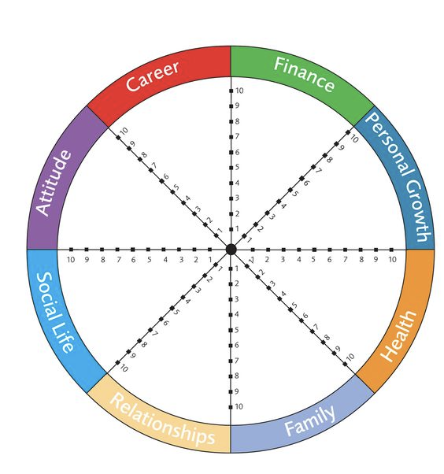
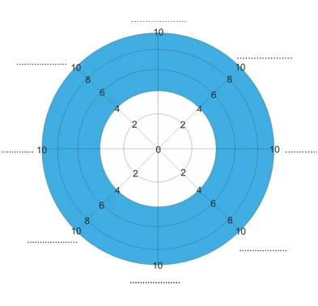

Appendix 2: Weekly Review Checklist

 | Task | Notes
1. | Review and celebrate your successes from the previous week. | Review, note, and celebrate your successes from the previous week.
2. | Close open loops from the previous week. | Review your email, physical mail, to-do app, note-taking tools, paper notes, and any other places you save items for later review during your day-to-day activities. List the open loops that need to be addressed in the coming week.
3. | Check your progress on your monthly goals. Course-correct if necessary. | Assess your weekly goals against your monthly goals to make sure you have the correct focus for the week ahead and are making progress toward your monthly goals.
4. | Set your top three priorities/goals for the coming week. | Set your top three priorities and goals for the coming week. Write them down so you can review them the following week.
5. | Set your daily goals priorities/goals | Set clear daily priorities and for the coming week. Identify three priorities for each day and determine what is the one Most Important Task (MIT). The MIT is the one thing you will get done that will determine if your day was a success.
6. | Add all your to-do tasks into your task manager. | Be sure you’ve included everything you identified from your open loops.
7. | Block out the time you’ll need for your top priorities on your calendar. | Block off time on your calendar for your daily priorities.  Be sure you’ve blocked off time for your recurring events, especially ones that will help you maintain the priorities you outlined in your Wheel of Life. For example, workouts, time for deep work, learning sessions, family time, a weekly strategy review session, and recovery time. Adding blocks of time to your calendar will also help you get into flow.

Copyright
© 2020-2023 by Syntopical, LLC and Stamina Lab, LLC
This publication may be redistributed, with attribution, in its original form, without permission. Any other excerpting or reuse requires permission from the authors.

Version: 12.15.22.1 Word

